Problem 1 : Accelerate the Car (20 Marks)

**Answer:**

class Car{

private int year;

private String make;

private double speed;

Car(int year, String make, double speed){

this.year = year;

this.make = make;

this.speed = speed;

}

public int getYear(){

return this.year;

}

public String getMake(){

return this.make;

}

public double getSpeed(){

return this.speed;

}

public void Accelerate(){

this.speed++;

}

}

class RaceTrack{

public static void main(String... args){

Car c1= new Car(2018,"Mahindra XUV300",130.0);

Car c2= new Car(2020,"Mahindra XUV500",150.0);

Car c3= new Car(2022,"Mahindra XUV700",180.0);

System.out.println(c1.getYear()+" "+c1.getSpeed()+" "+c1.getMake());

System.out.println(c2.getYear()+" "+c2.getSpeed()+" "+c2.getMake());

System.out.println(c3.getYear()+" "+c3.getSpeed()+" "+c3.getMake());

c1.Accelerate();

c2.Accelerate();

c3.Accelerate();

System.out.println(c1.getSpeed());

System.out.println(c2.getSpeed());

System.out.println(c3.getSpeed());

}

}

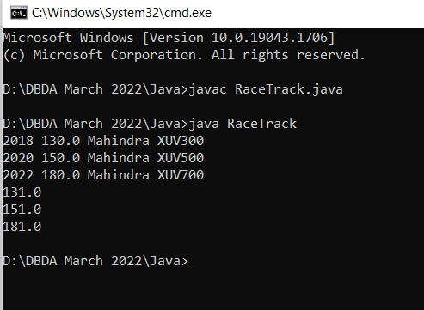

Problem 2 : Inventory Management (20 Marks)

**Answer**:

class Inventory{

static Item I=new Item();

static ArrayList<Item> list=new ArrayList<> ();

public static void main(String[] args){

Scanner sc=new Scanner(System.in);

int choice;

Item I1=new Item(1,"Item1");

Item I2=new Item(2,"Item2");

list.add(I1);

list.add(I2);

do{

System.out.println("Enter your choice ==");

System.out.println("1) Add Item.\n2) Display complete inventory in sorted order of item names as well as itemId.\n3) Remove Item.\n4) Exit");

choice=sc.nextInt();

switch(choice){

case 1:

System.out.println("Enter your details as follows");

System.out.println("Enter Item you want add");

for(int i=1;i<=1;i++){

System.out.println("Enter id of item ");

int d=sc.nextInt();

I.setitemId(d);

System.out.println("Enter name of item ");

sc.nextLine();

String ss=sc.nextLine();

I.setitemName(ss);

if(!list.contains(I)){

list.add(I);

}

}

System.out.println("Added items as follows");

System.out.println(list);

break;

case 2:

System.out.println("before sorting");

System.out.println(list);

System.out.println("Sorting by id");

idsort n2=new idsort();

Collections.sort(list,n2);

System.out.println(list);

System.out.println("Sorting by name");

namesort n1=new namesort();

Collections.sort(list,n1);

System.out.println(list);

break;

case 3:

System.out.println("List as follows");

System.out.println(list);

System.out.println("Enter index od item which you want to remove index start from 0");

int re=sc.nextInt();

list.remove(re);

System.out.println("List after removal");

System.out.println(list);

break;

case 4:

System.out.println("Thank you");

break;

}

}while(choice!=4);

}

}

